QUESTIONS:

Select all columns from the contact table where active flag is 1

**Ans:-select * from table_contact where Active_flag=1;**

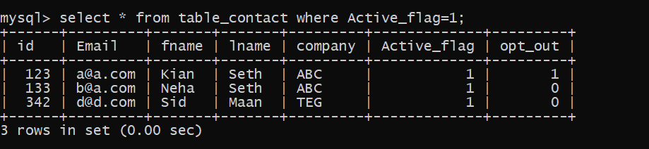

Deactivate contacts who are opted out

**Ans:- select * from table_contact where opt_out=1;**

Delete all the contacts who have company name as ‘ABC’

**Ans:-delete from table_contact where company='ABC';**

Insert a new row with id as 658, name as ‘mili’ , email as ‘mili@gmail.com’, company as ‘DGH’, active flag as 1, opt out flag as 1

**Ans:- insert into table_contact values(658,'mili@gmail.com','mili','Maan','DGH',1,1);**

Pull out unique values of company column

**Ans:- select distinct company from table_contact;**

Update name mili to niti

**Ans:-update table_contact set fname='niti' where fname='mili';**

**Screenshots of SQL contact table assignment**

